Question 9

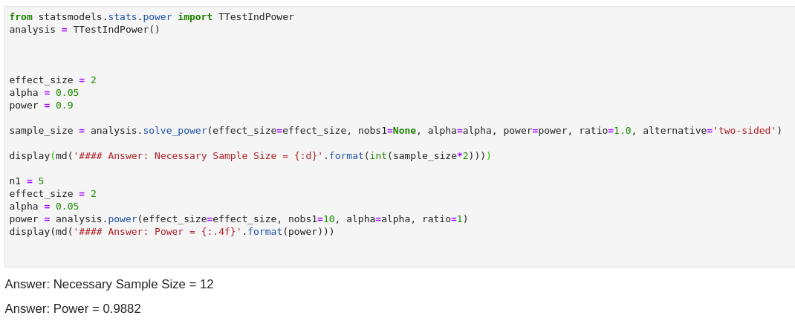

Assuming, alpha = 0.05

For the first question, given the difference of 2 and the power of 0.9 we need 12 observations for power of 90%

If we can only run 10 samples then we need a power of 98.82%